Around the Film Industry (Module 4)

Miguel A. Urrutia, Dominic Cortez, Adam Resendez, & Teresita Perez

CIS 3100, Stefan Bund

**Abstract**

*Results*

Method 1: Used PESTLE to study the film industry, Politics, Economic, Social, Technology, Legal, and Environment. Legal and Social issues. Issues such as Hispanic discrimination, Sexual Harassment, planet friendly equipment and economic movie distributions.

Method 2: Analyzing Comcast and Netflix marketing strategies we found out that Comcast is much more business to business oriented where Netflix is business to consumer oriented. 10k reports produced evidence that Comcast had been investing in more infrastructure and innovation while Netflix is investing in advertising and marketing. From our five forces analysis we saw that one of the major risks that both Comcast and Netflix are facing is cyber security. Following with the information we obtained we asked an IT specialist from a payroll service company called Cast and Crew about the security threats. The greatest threat to the industry for cyber security is human error.

Method 3: With a well-researched swat analysis in method 3, we were able to conclude the reasons why the industry can strive even when the is economy is in a recession by identifying the areas that are challenging to the industry

Method 4: Referring to the text, we were able to identify the types of revenue models that firms in the film industry utilize, the benefits and consequences that come with innovation, and the relatively new form of backing a project found in crowdfunding. We found these four aspects of business to be relevant in the film industry because they not only make the difference of getting the competitive advantage above other filmmakers, but most importantly if that firm can even enter the market in the first place. Many successful businesses that have employed these tactics are now thriving in our society today- Netflix being a prime example of this- that have crept their way into becoming household names.

Method 5: We concluded that having a informational system is extremely important in the film industry since there are many forms in which data needs to.

Method 6: Interviewed two film industry professionals they were from payroll casting crew and a director in operations organization development from Warner Brothers Entertainment.

Method 7: Referred to Chapter 10 by looking into some past technological breaches that occurred in the industry we determined the importance of having a strong cybersecurity system and the importance of having a plan in case a breach occurs.

Method 8:

Constructed Ishikawa resulting in deduction of root cause. Increase in global market presence, new technologies, and political agenda; the movie industry has become too formulaic; Movies dramatically undersell domestically compared to internationally.

Method 9: Referred to the textbook and looked at the software and cloud usage and their importance in the success of a firm competing in the film industry. Also looked into the security issues that film industry faces such as, Criminals and Crimes, Cyber Terrorism and Piracy, Managing System Security, and ways to developing a security strategy.

Method 10: Abstract for chapter 4 By looking into the importance of a using virtual site we concluded that industry’s need to have an appealing website that is functioning properly and is secure to use.

**Method 1:**

Research through PESTLE acronym standing for Politics, Economic, Social, Technology, Legal, and Environment. Legal and Social issues in the film industry have caused social movement that targets individuals who are charged with sexual harassment, are now being brought up to the open public. Politics discrimination toward minority like Hispanics can potentially affect the film industry sales. Environment and Technology a great majority of film industry are going green and are doing so by switching from gasoline fuel-based technology to electric power technology, reusable water and reduced waste. Economics for the film industry show that big name production companies are focusing on high end movies like, super hero movies due its high profitability in merchandise.

*Legal and Social*

Film industry faces a growing number of sexual harassment report which started when Harvey Weinstein was accused of sexual harassment back in October 2017.1 Harvey Weinstein is a well-known film producer and during the investigation, it was revealed there had been three decades worth of undisclosed sexual accusations which led to his arrest.1 Weinstein arrest created a social movement called Weinstein effect, in which other actors, directors, and politicians are accused of sexual harassment. In The New York Times they have a list of 71 men who were accused for sexual harassment and have resigned from their respected occupation.2

Producers Guild of America (PGA) are implementing new guidelines to fight against sexual harassment in movie production sets. These are just guidelines meaning it is just an informational reminder to respect each other. However, producers can leave the PGA when they like to and not be bound by the new guidelines.4

*Facts*

USA TODAY created a survey done to a group of 843 women who work in the entertainment industry asking them if they had been in some way a victim of sexual harassment. The result was that 94% of the women surveyed responded with a yes, in having been a victim of sexual harassment. In the survey, the lists show the types of sexual harassment one experiences, unwelcome sexual comments being the top of the list. 3

*Politics*

Trump's border wall and discrimination towards the Latino can lead to fewer Latino moviegoers.5 According to Theatrical Market Statistics, it shows that the second largest group of moviegoers are Hispanics/Latinos and just recently in 2016 the number has gone up.5 Political pressure that is dehumanizing Hispanics, and the lowering the number of Hispanic lead roles. Could eventually discourage Latinos moviegoers, a reduction that will hurt sales.5,6

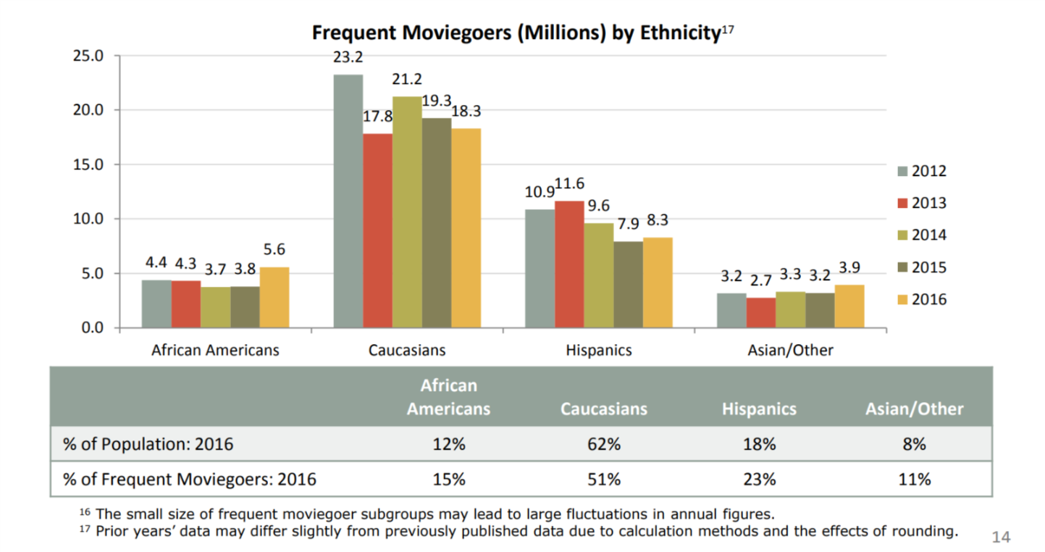7. Moviegoes according Motion Pictures Cinemea, Theatrical Market Statistics

*Environment and Technology*

Colombia University journal page State of the Planet writes on how the movie industry is working on reducing its environmental impacts. Such as reducing Carbon and Green Gas Offset, Waste Diversion, Transportation, Water Use Reduction and Energy Efficiency. Carbon and Green Gas which is created from traveling to movie sites, transporting supplies, power generators, and pyrotechnical equipment. Film Industry companies like 21st Century Fox has contracted a third-party company to help the company stay on track, help improve the reduction of carbon emissions. As well as, PGA implementing guidelines for the movie production. Waste is caused by actor props, backdrops, movie set props, and leftover food. So, companies like Sony Pictures located in Culver City CA have partnered up with the city to donate, instead of throwing it away as waste. Transportation is one of the largest greenhouse gas contributors so companies like CBS Entertainment are beginning to use hybrid vehicles and completely electric vehicles to reduce carbon emissions. Water is being conserved by industries like NBC Universal that are recycling rainwater and installing water filtration systems to reduce plastic waste. Energy efficiency like Warner Brother Studios which have installed solar roofs that are helping them run their studio. 8

*Economic*

Money is being a concern in the film industry as there is not much money that comes in from movie rentals and sales. Film industry is focusing more on blockbuster production that will have more life value opposed to smaller films. Example Avengers movies have a large return value as there is products that can be sold to the fans from costumes, toys, collectibles and other items. Small films are being sponsored by online network companies like Netflix and Amazon due to their unlimited budget from subscription. A new trend that is coming up is the China investing some of the cost of production money, in exchange for having their Chinese Actor an Actresses to have a leading role.9

**Method 2:**

*10k financial analysis repots and Five Forces*

First task was to analyze the 10k financial reports of some of the major companies in the industry and compile the information to see if there was some sort of trending activity that’s happening in the industry. The second task was to construct a “Five forces” graph and do the industry analysis. Lastly was to see the distribution of wealth compared to the geographic location of the business.

After putting together the 10k reports and analyzing the individual firms we were able to come to the follow conclusions. The industry is overwhelming aware of the risk of consumer power. Each firm was scared of losing consumer base to political, environmental, and competitive elements. Their main prerogative seemed to address that they were doing everything in their power to remain on top of trends, stay in good political light, and remain cost efficient for consumers. This was one trend that arrived at each of the companies making 5-7% increase in revenue this past year. Another risk factor each of them listed was that technology was creating too many alternatives to the industry and that it could eventually cause a loss of viewership or subscribers. For Viacom, these were the only two risks listed, however Netflix and Comcast both shared a third risk was that the viewership/subscribers would decline because of inability to provide service to their growing consumer base. The operating expenses for each firm chosen had gone up 9%-11% according to their 2017 10k reporting’s.

The last portion of the was to analyze the top five geographic locations of these business and to see where the wealth distribution was. We discovered on the census website that there was a listing of earnings done by the census based on the geographical location already. We took this data put it into excel and graphed it to produce the distribution of wealth based off of number of companies in the geographic area.

Profitability decreases as competition increases. Three of the five forces relate to industry participants The other two relate to the vertical components – suppliers and consumers.

1. How competitive is the industry as it stands Comcast, Netflix, Viacom
2. How easy is it for new players to enter the industry – Netflix , Viacom
3. How possible is it for new product to disrupt chain. – Netflix, Comcast,
4. How accessible are the suppliers of the raw material - Viacom
5. Consumer has bargaining power? erodes profitability. Netflix, Comcast

as defined by Porter’s 5 forces.10

1. Comcast, Netflix, and Viacom all listed amongst their risks in their 10k that the competitiveness in the industry was a main concern.
2. Netflix, and Viacom specifically worried about entry to the industry stems from multiple directions.
3. Netflix worried about piracy and other new entries to the streaming world. Amazon Hulu etc. Comcast worried that new providers and mobile carriers will start stealing customers.
4. Viacom – not necessarily worried about raw materials, but they’re first listed risk and concern is to stay ahead of trends and maintain attractive content. Netflix is worried they might have too many subscribers which their platform might suffer technical issues.
5. Netflix is worried about losing subscribers, Worried about becoming too large to afford their audience/ rising prices of technology and consumer demand creates for hard field.

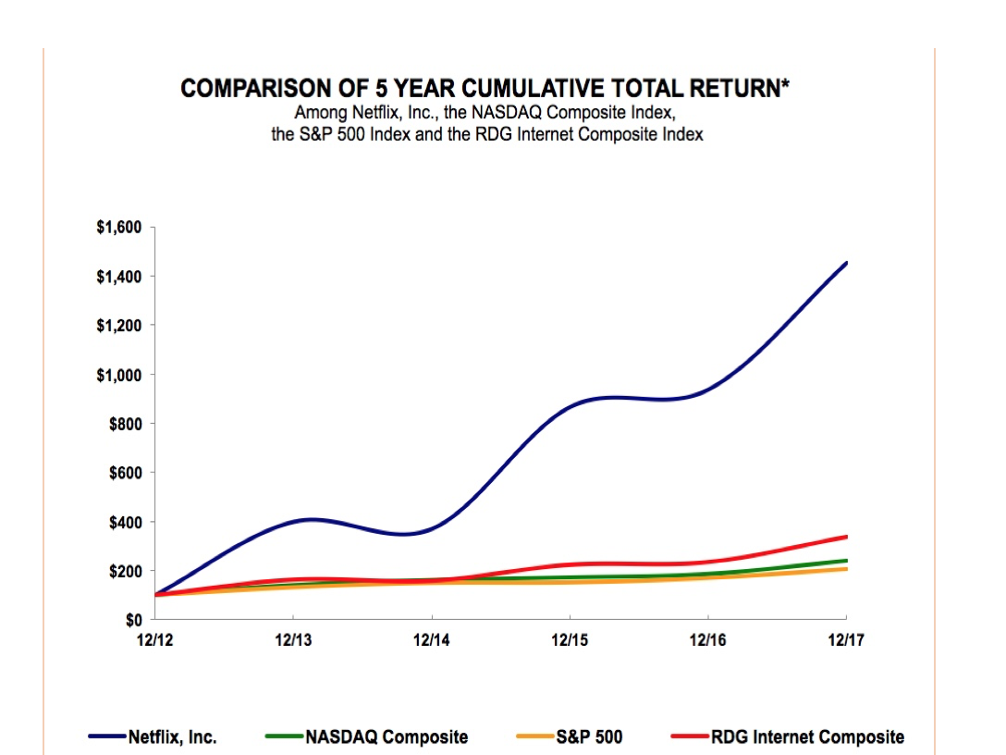

Total Revenue of Industry distributed across geographic location

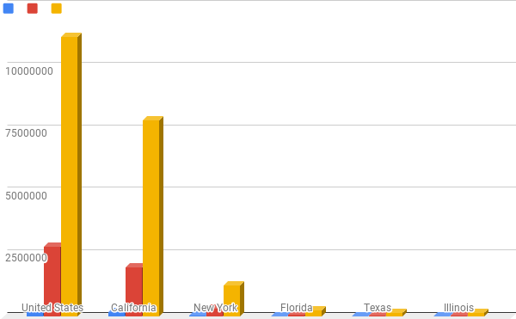

I gathered more information about business strategy and business planning from the giants we had already analyzed. The business strategy remains clear for Netflix and Comcast; subscribers are the key; Comcast’s marketing strategy remains to be at the center on the innovation of business to business platforms32. While Netflix maintains a consumer orientated agenda. Comcast has multiple outlets of media that are more traditional and just as relevant as Netflix. Comcast hosts magazines, television programs, streaming services, and more; but Netflix has the market majority of the streaming sector which has been a leader in market growth. Netflix has a total of 47 million subscribers followed by Comcast at 22.4 million subscribers.33 Despite the fact the Netflix has such a huge percentage of the market share, they are still investing in marketing and just last year had increased their marketing spending by 50% according to The Motley Fool 34. Which was apparent in our 10k reporting that we found Netflix had increased their expenditures specifically on marketing.

We had to follow the trail of money to get some in depth information as to how Netflix was attempting to reinvest their money and what marketing strategies they were following. The most recent marketing strategy that I could find was from 2014 and highlighted how they were dominating the DVD market and understood that this could face environmental challenges in the future. Their plan was to remove the need for DVDs and yet still get consumers the content that they wanted by producing a coherent and well-designed streaming service. They also highlighted that they wanted to improve their algorithms in determining the best possible movie match for the viewer stressing that you can watch what you want when you want. 35

Comcast was not as interested in streaming revenue as it was in continuing to expand its already 111.4 million broadband users.36 Instead Comcast focused on their business to business strategy; expanding VoIP, broadband internet, cable television, and lastly home security. We saw a major parallel between the two industries on how they approach innovation and also how they approached security. The outlier of these two industries were simply the market share that they were after. 37

Netflix and Comcast have both a firm understanding of what positions in the industry they want to pose for regarding consumer interaction. Comcast has much less of a business to consumer model than Netflix which is apparent in their investing. Comcast is not investing in marketing because it remains borderline monopoly status with its coverage of consumers of the United States. Since we could not obtain any security insight aside from level one customer support from Comcast; we obtained some answered questions from an IT professional in a Payroll service associated with major film and production studios.

**Method 3:**

*Strengths*

The top ten Film Production Establishments are: Warner Bros., Sony Pictures Motion Picture Group, Walt Disney Studios, Universal Pictures, 20th Century Fox, Paramount Pictures, Lionsgate Films, The Weinstein Company, Metro-Goldwyn-Mayer Studios and DreamWorks Pictures. These companies are dominant in the motion picture production. They have created strong recognizable brands using large capital which facilitate fast film production. Due to their combined monopoly, entry for smaller companies to join the industry is incredibly difficult. The revenue gained from the motion pictures is significant. This revenue is comprised of theaters box office sales. digital downloads, DVD sales, and content licensing. Furthermore, as a low cost form of entertainment, movies create an advantage to the production companies due to their profitability during economic booms or economic recessions. 11,12 The graph below demonstrated the high revenue gained from a successful film.31

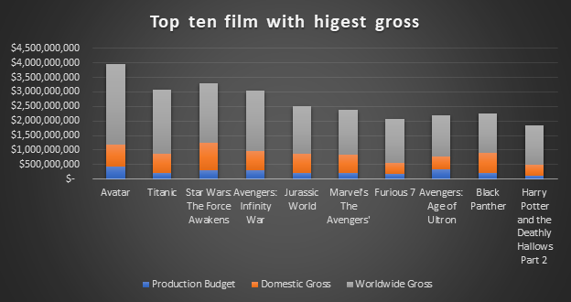

*Weakness*

Operation costs require large amounts of capital. Frequently, various permits are required when doing a motion picture production. For example, permits are required for employing minors, filming in highways, freeways, beaches or parks, using drones, and the usage animals. Also, film production companies heavily rely on advertising which further adds to the marketing costs. Lastly, film production companies often employ union workers which adds additional operation costs with increased labor costs. 14,13 The graph above reveals the weakness in the movie and production industry by taking a look at the overall revenue needed for production.31

*Opportunities*

There is always opportunity’s for new film to be created but to truly grow, expand their brand and increase production revenue is by Globalization. Having international growth in different countries is an opportunity many production companies need to take. There is an opportunity of growth by innovation due to the increase technological advances. Currently, watching film has become easier by streaming and accessibility; therefore, long-term distribution agreements can serve as a mechanism for film production companies to control the markets. 11

*Threats*

Competition is one of the biggest challenge production companies face. These include other large motion picture producers, streaming company’s such as Netflix, global competitors, cable networks, etc. This is compounded by the fact that all the production companies have the same target audiences. Films must be meticulously released to limit overlaps of release dates of movies of similar content or genres between major competitor release dates. Additionally, an increasing threat to film production companies is digital piracy. Companies have begun to employ expensive technology to combat piracy to minimize the potential loss in revenue. Although these technologies have slowed the increase in piracy, they have yet to successfully deter the illegal digital piracy. 12

**Method 4:**

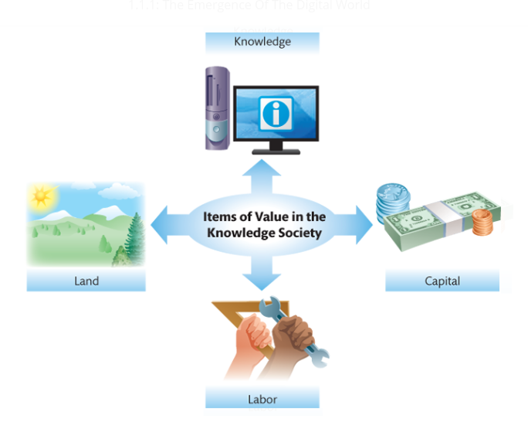*Knowledge Society*

In 1959, a man named Peter Drucker predicted that information and information systems would become increasingly important, and at that point, he coined the term [knowledge](https://etext.pearson.com/eps/pearson-reader/api/item/28eb7558-73a3-4aea-b086-6aea15a960af/1/file/valacich_schneider-ist-8e_eT2_v1/OPS/xhtml/glossary.xhtml) worker. Drucker also predicted that along with the growth in the importance of knowledge workers, a knowledge society would develop.15 This diagram in the textbook shows what different items are important to the “knowledge society” that Drucker predicted half a century ago. In relation to the movie industry, all of these items are essential when it comes to the production of a movie. Land is key when filming a movie because it is where the cast and crew will spend months on end working to make their product- whether it be a movie lot that the company already owns or an entirely new scenery that they have to pay in order to use. In our society today, many would consider capital to be the blood of any industry because of the power that it holds. Capital can give a firm a competitive advantage when it comes to producing movies because that can be money invested in getting the best actors, the correct equipment, correct costumes, or making sure that they have the best people and software to making the CGI look as realistic as possible. Along with these people that are working in front or behind the camera or working behind the computer, there are those that are working tirelessly to build the sets that we as the audience sees on the big screen or even those that have to move around the heavy equipment safely from location to location. The labor force is something that is not usually the first thing to pop into our minds when we think of movie production, yet it is still a crucial aspect that cannot be overlooked. The last aspect that is a key player in a knowledge society is, knowledge. Although knowledge is a broad spectrum, we will look at the knowledge needed to handle the hardware and software that a firm relies on to function. In movie production, extensive knowledge of the equipment can be used to the competitive advantage of a company when making a movie because this can allow for the most creative ways to get a scene shot or enhance the special effects used to impress the audience. Having all of these aspects of a knowledge society come together in the most effective method possible will ultimately decide if a movie will be a commercial or critical success.

*Globalization*

Globalization is a process that is taken into account when making movies because of the prospective financial success that can be earned if the movie is selling in theaters across the globe. A modern-day example that benefited as a result of globalization is the recent release of “Bumblebee”. The film made $124,253,188 domestically; while a sizeable amount of capital this is 11 million dollars short of its budget.16 Luckily, because of the process of globalization, “Bumblebee” was able to rake in an extra $331,000,000 and surpass its original budget.16 Globalization also benefits more than just the big production companies that make the many hits pay to see in theaters. Any streaming service- whether it be Netflix, Hulu, or Amazon Video- is affected by globalization because their services are available to almost every country in the world. “This is made possible by the by falling transportation and telecommunication costs.”15 Whether or not a production company decides to utilize globalization will determine their future as a firm within the industry.

*Technical Competency*

Having personnel that not only simply know how to operate the hardware and software of a business, but to do it efficiently can put a firm at the top of the business.

*Five IT Megatrends*

There are five IT megatrends that have developed as a result of the development in web technologies that are influencing individuals, organizations, and society as a whole.15

1. **Mobile:** With this new level of mobility thanks to the innovations with smart devices, movies can now be viewed anywhere instead of having to go to the theaters. This allows for a larger amount viewers to watch the movie whether they want to see it in the comfort of their own home, during their breaks in between work, or even while they’re waiting in line for their cup of coffee. Smart devices allowing the viewing of movies to be ubiquitous has gained companies not only a growth in capital gain, but in cultural relevance as well.
2. **Social Media:** Social media and the topics discussed trending within it have almost become impossible to avoid. Streaming services such as Netflix and Hulu have gained more popularity through the use of social media as people begin to create buzz for its products. This trend can be particularly seen most recently with the Netflix original “Bird Box”. The amount of people talking about the movie was astounding in the initial weeks after its release that there was an internet trend in which millions of people participated. This increase in recognition can drastically affect the stock prices of these companies and in order to maintain their level of popularity, these services must keep creating more content for its consumers to enjoy and spread word about.
3. **The Internet of Things:**  A network of a broad range of physical objects that automatically share data over the Internet.15 This can apply to almost everything electronic in our lives today- especially our smartphones. Whenever we view something on our phone, this data is then sent to companies that can then produce ads for various things that peak out interest. This can apply to moviegoers because if Instagram, for instance, has noticed that a user has “liked” posts related to superheroes, action, or drama, this information can then be used to tailor advertisements for movies related to these genres. However, this innovation in technology increases concern when it comes to digital privacy.
4. **Cloud Computing:** Much of the functionality previously offered by applications installed on each individual computer is offered by applications “in the cloud,” accessed via a web browser.15 This is useful for moviegoers because the information of showtimes and movie reviews are now readily available in an instant.
5. **Big Data:** Coming with the increase in technology development was the amount of data that could be stored. This means that now more than ever we can store ridiculously large amounts of data online- one being movies. This can be a good or bad thing for production companies because they can now have their movies online digitally. This allows for more people to view their movie because it is a cheaper alternative than buying a movie ticket that is far more expensive.

*Intellectual Property*

Any creations of the mind that have commercial value is considered Intellectual Property.15 Movies are considered Intellectual Property because other people will pay in order to consume/watch it. However, anyone can find said property online and pirate it instead of having to actually pay for it. If this were to occur, this can hurt a company’s profit if enough people follow this route because why pay for a movie at all if you can get it for free? This causes many legal and ethical questions as to who is correct when it comes to these issues. These technological developments are a double-edged sword that needs to be used carefully.

*Business Competency*

People that know how to deal with and manage people more than just how to operate the equipment are crucial to a firm’s workforce. Hollywood executives can be rather picky people and have a large say in how a movie should be made, but a worker that knows how to handle them can mean more time or money for the project’s completion.

*Information Systems for Competitive Advantage*

Many movie theatres offer rewards programs for those who decide to sign up. This is important for membership retention because there are various special offers that these theatres give for signing up for these programs. For instance, the popular theatre chain Edwards Cinema gives its rewards members birthday gifts and this is made possible with the use of Information Systems for keeping track of such information. The efficiency of these Information Systems can help theatres such as Edwards gain a competitive advantage over, say, Harkins because they used this not only collected this Information, but also used it in a way that will attract more customers to their doors.

*Information Technology*

Information Technology is important when it comes to the development of movies. The hardware that is used in this process are the computers used to edit and store the footage of the movie while the software is the different programs used to edit the footage together or generate CGI. The telecommunication networks that are used in the film industry can be seen whenever a movie is watched online through a streaming service because our computers must connect to the networks in order for it to play.

**Method 5:**

*Revenue Models*

There are many revenue models that the firms within the film industry use. Subscriptions are seen utilized by the big-named streaming services such as Netflix, Hulu, and Amazon video in which the consumer must pay a monthly fee in order to continuously use their service. Traditional sales is another- and quite easily the most basic- form of revenue for film companies because it occurs whenever a customer buys a product or service from that company- i.e. buying a movie ticket or buying/renting a digital download of from their service. Another main form of revenue that many film firms use is advertising. This is seen most commonly with the video-sharing website YouTube. Before your video loads, another short one plays before it is advertising another company’s product/service. This means that the company that the ad is displaying is paying YouTube, giving YouTube enough revenue to allow it to remain a free-to-use service. Along with advertisements, YouTube also has the Freemium feature YouTube TV. This still means that YouTube is a free service but if a consumer pays a premium charge then they have the privilege to watch the site’s exclusive content.17

*Innovation is Often Risky*

Thanks to the numerous innovations to cameras and film equipment in general, we have been able to witness an increase in film quality. A summer blockbuster that came out in 2018 will have significant improvements than that of one released in 2008. Some of the developments that these companies make has the potential to run other firms out of business. This can be seen with the marginalization of film cameras due to the widespread use of digital film cameras in the later half of the 20th century as well as camera drones minimizing the need for helicopters to get aerial shots. The decision to use a drone makes more fiscal sense because the price of a camera drone can range from $30 to about $3000 depending on the quality of the drone whereas the price to rent a helicopter ranges from about $200 to $1000 per hour.18 However, along with any innovation comes the copycats and one of the main way companies protect these is applying for patents. One recent example of a major movie company doing this is with their recent release “Spider-Man: Into the Spider-Verse”. Sony did not waste time meticulously animating every second of their work with its largest team of animators- 140 to be exact- with which the company had ever worked. And it paid off as the movie received a Golden Globe for this achievement. Now the company wants to keep a hold on their animation process and the technology that they used to ensure that no one else can replicate it exactly the way that they did.19 Innovations are an important competitive advantage in any industry and companies need to make sure that they keep theirs safe at all costs.

*Open Innovation*

From a certain perspective, every movie that a company makes is an innovation as it is a product that returns value to the organization from its sales. Open innovation is the process in which external stakeholders can have a say in the innovation process. This is seen with all kinds of different movies as the producers of the movie can have an opinion in which the direction the movie should go. Their opinions can either benefit or hurt the final product, but in the end, what they say- for the most part- has to be done because it is their money that is funding the creation after all.

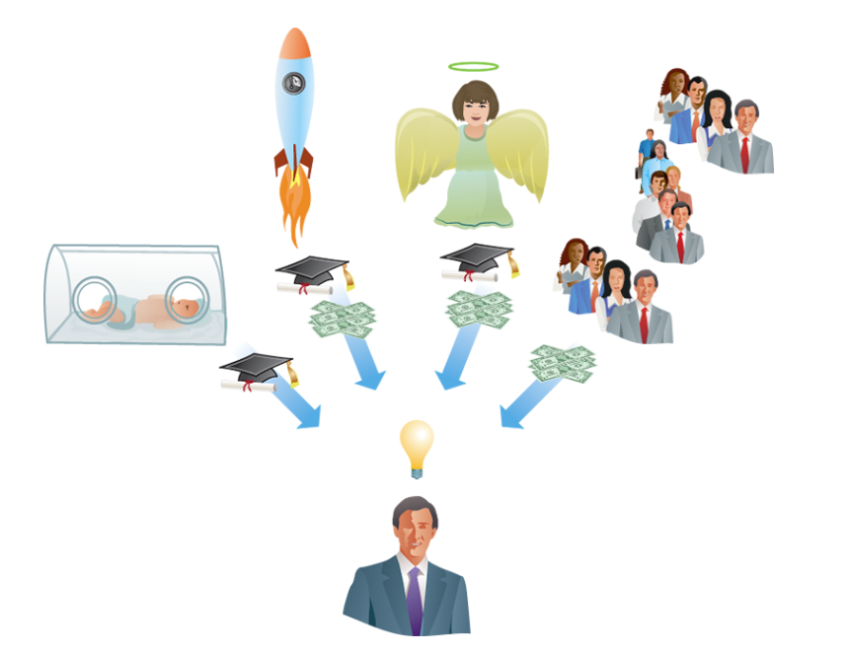

*Crowdfunding*

Crowdfunding has become a prominent way of having small-scale movies or miniseries produced. Kickstarter, Indiegogo, and Patreon have become some of the most prominent names when it comes to crowdfunding. All of these websites accomplish the objective of having a crowd-funded project being produced but the one that many YouTube creators turn to is Patreon, a subscription service that supports small creators in their endeavors to keep creating videos. Some popular examples are the high-quality education channel Crash Course, the A Capella pop singer Peter Hollens, and countless of others.20

*System development lifecycle*

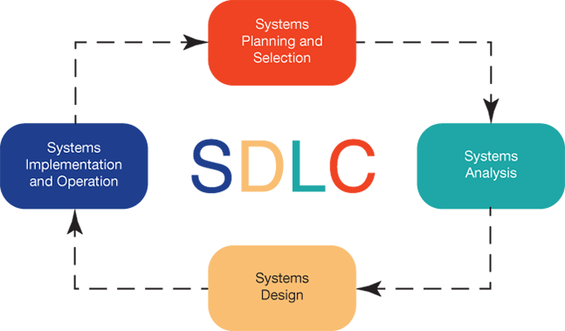

As demonstrated in the diagram above, the system development lifecycle is broken down into 4 phases from the beginning to the end of the cycle. These cycles move from planning and selection to system analysis then to system design. Finally, the cycle ends at the system implementation and operation. 23

*Phase one: Systems Planning and Selecting*

In the beginning of the system development lifecycle, we have the systems planning and selection. It is important to identify the different types of projects available. Since this system only works with one project at a time, identifying and selecting the best project that will enable the organizational goals is crucial in decision making. Once the project is selected, planning on how this protect will move forward is the next step. This is relatable to the motion picture and production industry, since many ideas for movie production will make its’ way into the lineup. As a result, it is important to evaluate all the possible outcomes.23 The one possible outcome that yield the best possible product is the movie that will be ready for production. Before it advances into production, a well-established plan is needed in establishing how to move forward. This system can also be implied once the production is complete such as when edits and special effects are being integrated in the film. A perfect example that demonstrates this phase is the movie Avatar produced by James Cameron. This production has the largest gross revenue of 2.7 billion 21 in sales. This film took approximately ten years in the planning before Cameron felt that the technology was advanced enough to take the movie into production.22

*Phases Two: System Analysis*

Phase two consist of gathering data, analyzing the data and distributing the information obtained from that data. Analyst work closely with users, managers, customers and business processes to gather the needed information. Some of the techniques used to gather information include questionnaires, interviews, observations, document analysis or joint application design that consists of a group of people coming to gather to agree on system requirements.23 This relates to movie production because gathering data is extremely helpful when doing a film. For example, information on types of actors can be essential when figuring out the right cast for a movie. Knowing the likes and dislikes of customers by gathering questioners and even gathering data on songs to add affect to the movie’s scenes can be helpful in making a successful film. When producing Avatar, Cameron wanted to enhance the movements and facial expression of the avatar giving them a more realistic digital lifeform. Cameron worked with a group of artists to figure out how the they could accomplish this. To get the movements they film using motion-capture technology that had the capacity to record in a 360-degree angle allowing them to capture every move.21 They gathered data by filming the facial expressions up close to get a more accurate facial movements and expressions. These were then later digitally inputted to get a more realistic avatar. Without data movie production would be extremely difficult resulting in a low budget movie with hardly any success. Information systems are useful in production since it requires extensive data to be gathered when making a production, for instance Black Panther, produced by Kevin Feige, required data collection from the Marvel comic books, site location, music, well as gathering cultural data; they analysis that data and constructed it into the production.

*Phase Three: system Design*

The third phase, system design consists of building an information system. When constructing an information system using the processing and logic operation allows for raw data to be converted into new information.23 The new information can be constructed into structure charts, decision trees, programing code, pseudocode, flow charts which will eventually be converted into code.23 Another process is designing database and files. When designing a database, it is important to design it based on the needs of the organization. For example, in the movie industry a data base can be constructed for employees. This can be useful to track the number of employees, track the hours worked or their schedule.

*Phase Four: Implementation and Operation*

The last phase, implementation and operation occurs when the information system is programed, installed, tested and supported.23 when testing for a system there are 3 different types of test that are conducted to insure the system is running properly. Development testing is conducted by programmers in which they check individual modules for errors. The next test is called the alfa testing were a software tester test the overall system to make sure its design is functionally accurately. The final test is called beta testing were users test the system using actual data to test the capabilities of the information system. When it comes to the motion picture and production industry this phase is equivalent to reviewing editing and making corrections to a film before it is made be available in the big screens.

**Method 4:**

*Interview 1*

I gathered more information about business strategy and business planning from the giants we had already analyzed. The business strategy remains clear for Netflix and Comcast; subscribers are the key; Comcast’s marketing strategy remains to be at the center on the innovation of business to business platforms24. While Netflix maintains a consumer orientated agenda. Comcast has multiple outlets of media that are more traditional and just as relevant as Netflix. Comcast hosts magazines, television programs, streaming services, and more; but Netflix has the market majority of the streaming sector which has been a leader in market growth. Netflix has a total of 47 million subscribers followed by Comcast at 22.4 million subscribers.25 Despite the fact the Netflix has such a huge percentage of the market share, they are still investing in marketing and just last year had increased their marketing spending by 50% according to *The Motley Fool*26. Which was apparent in our 10k reporting that we found Netflix had increased their expenditures specifically on marketing.

We had to follow the trail of money to get some in depth information as to how Netflix was attempting to reinvest their money and what marketing strategies they were following. The most recent marketing strategy that I could find was from 2014 and highlighted how they were dominating the DVD market and understood that this could face environmental challenges in the future. Their plan was to remove the need for DVDs and yet still get consumers the content that they wanted by producing a coherent and well-designed streaming service. They also highlighted that they wanted to improve their algorithms in determining the best possible movie match for the viewer stressing that you can watch what you want when you want.27

Comcast was not as interested in streaming revenue as it was in continuing to expand its already 111.4 million broadband users.28 Instead Comcast focused on their business to business strategy; expanding VoIP, broadband internet, cable television, and lastly home security. We saw a major parallel between the two industries on how they approach innovation and also how they approached security. The outlier of these two industries were simply the market share that they were after. 29

Netflix and Comcast have both a firm understanding of what positions in the industry they want to pose for regarding consumer interaction. Comcast has much less of a business to consumer model than Netflix which is apparent in their investing. Comcast is not investing in marketing because it remains borderline monopoly status with its coverage of consumers of the United States. Since we could not obtain any security insight aside from level one customer support from Comcast; we obtained some answered questions from an IT professional in a Payroll service associated with major film and production studios.

*Interviewee*

Since two of the major three companies had focused so heavily on security concerns we thought about asking an expert of the IT field from Cast And Crew; a payroll service for the Movie production and film industry. This gave us the ability to answer a few key questions. Following Porter’s five forces, we asked questions involved with threats and security, innovation in technology, chain of command for problem-solution scenarios, and routine day-to-day protocol.

*Interview Questions with Service Desk IT Expert*

What are your biggest threats for your company and what tools do you use to analyze these threats?

* Threats – Phishing email scams where emails are disguised as credible sources and lack of technological experience from employees.
* Tools used to analyze – Specific spam recognition software that catches some or most of the scam emails.

What are innovations in technology that you foresee playing a bigger role in the industry in the future?

* Automation – rapidly taking over technologies that an IT would normally interact with. Programming scripts and algorithms are getting increasingly good at fault prevention.

What tools do you use to form measurable objectives and performance targets. How do you craft a strategy to achieve those goals?

* Ticketing systems that would take advantage of gathering as much information about the problem and from there interaction is escalated based on problem complexity.

What would be the routine, day to day business process and interactions with customers

* Interactions come from ticket system unless there is a larger infrastructure problem. Again broken into different tier systems to be managed by different level of experience technicians.

What would be the chain of command for interacting with a problem/solution scenario. From bottom up.

* Initially the employee facing the issue would try to solve it with the end-user. If issue persisted it would continue up the chain through IT experts until network engineers are called out to location of issue.

*Results*

Gathering the information from the IT professional it became very clear why security was such a big threat to these companies. As cloud-based software becomes more and more apparent as years continue forward the day to day routine changes. It becomes less troubleshooting and more about the prevention of data mining or leaking thereof.

Since Casting and Crew is a payroll service, they themselves are the information system that some major Hollywood studios are currently subscribed. Most of the industry would be relying on services like these because as the company grows their need for professionals outside their specific industry become apparent. When cloud-based software become a strong integral part of a studio however the splitting of these two become virtually impossible and would require a long arduous process of restructuring the financial data that Casting Crew processes after working with a studio for a long time.

*Interview 2*

Yon Na works for Warner Brothers Entertainment as a Director in Organization Development. Interviewing Yon Na via email we got a chance to communicate and ask questions in the film industry.

*Interview Question and Answer*

*Who makes the executive decisions in the company?*

In the film industry executives make decision for the company when producing and distributing either a Movie or TV Show. The executives being the president and CEO are the ones that give an approving to whether give financial funding to a project. Executives also give the decision of distribution of a movie.

What is the competition like with other studio companies?

Competition for Warner brothers currently is not a threat at this point, since talent being starts, actors and directors have exclusive contracts with their company. However, Amazon and Netflix are beginning to give full creative license to their talent. Which in Hollywood does not give directors authority to have the final say on the films production. Unlike Amazon and Netflix giving the directors full freedom and resources to create what they want.

How is automation helping your company?

Automation in the company is using robotics to help finance by working on accounting calculations. Animation artists are using technology to save time in animating.

What kind of software does your company use in day to day activities?

Software used in the company ranges from Microsoft Office to advance Computer Generated Imagery (CGI). 1

*Results*

The film industry uses a lot of the applications from chapter 2 and are using technology on a daily basis from financing their projects to helping animation artist ease there work load and focus more on creating more content. When it comes to competition Netflix and Amazon are becoming a more favorable company for creating movies without restrictions.

**Method 8:**

*Method Ishikawa*

No information regarding overseas data was available from the census. We examined *boxofficemojo*’s³⁸ website, which reports the domestic and international gross of movie releases. We saw consistently that domestic gross was well under the international gross of movies. We saw that consistently movie domestic gross made up approximately 25% of revenue. Using this information, we sought out to see why the movie industry was reporting low domestic income percentages. Constructing an Ishikawa diagram, we centered around what we saw to affect domestic grossing prices.

First, analyzing the creative process of producing a video we looked at costs and production length. We saw on average movies took anywhere from 600-1000 days of production³⁹ and costs rose to well over $100 million dollars for the larger entities like Warner Brothers, Paramount, or Buenavista³⁸. The difference in price is what struck us the most and resulted in us looking at the costs of something that did relatively well for Netflix compared to a movie that was released in theaters.

We cross analyzed the movie *Wreck it Ralph 2* with movies like *Bird Box* and *High Flying Bird*. Wreck it Ralph’s 2 budget was just over $170 million dollars to produce and grossed just over $200 million with almost 40% of that being domestic.³⁸ Compared to Bird Box which cost just short of 20 million dollars which reportedly grossed $411 Million dollars according to Forbes. ⁴⁰ Since *High-flying-Bird* is still relatively new *the* information was not available; however, it still holds a 93% approval rating on Rotten Tomatoes. Some other major movies with scores in the 90’s, Black Panther, Get out, The Wizard of Oz, and Inside-Out. ⁴**¹** High Flying Bird cost just under $2 million dollars to produce.

Looking at the large production cost for Wreck it Ralph 2 we decided to check out why the costs were so high. Expecting that CGI costs were the result of the high costs for the production we looked into average costs of CGI. We saw that in shows like, Game of Thrones, CGI averages around $6 million dollars per episode ⁴². It makes sense that a lot more people are staying home and watching shows and television when this kind of money was being spent per episode on graphics.

But it is not only the increased production value of new shows; but rather an overall unwelcomed experience at movie theaters. We saw that although Movie Theaters had saw an increase in revenue last year, there were lower movie ticket sales and turnout than previous years. ⁴³ This led us to examine some of the reasons behind low ticket sales and what we know. Movie ticket prices have gone up and Public safety was called into question and we explored that area.

Mass shootings in the past three years have gone up by almost thrice the average of the last decade⁴⁴. With heated debate about the topic one can assume that movie goers will have in mind throughout their experience that there would be some horrific event. The fact is, media portrays mass shootings with intensity and unfortunately movie theaters have been a target in the past.  We saw the New York Times report that, in one study, 48% of individuals would agree to pay a dollar more for entrance to a movie for safety regulations like metal detectors or bag checks. ⁴⁵

We brought all of this information to one issue which we believed encompassed the root problem. The root we projected was that due to the increase in global market presence, new technologies, and political agenda; the movie industry has become too formulaic; Movies dramatically undersell domestically compared to internationally.

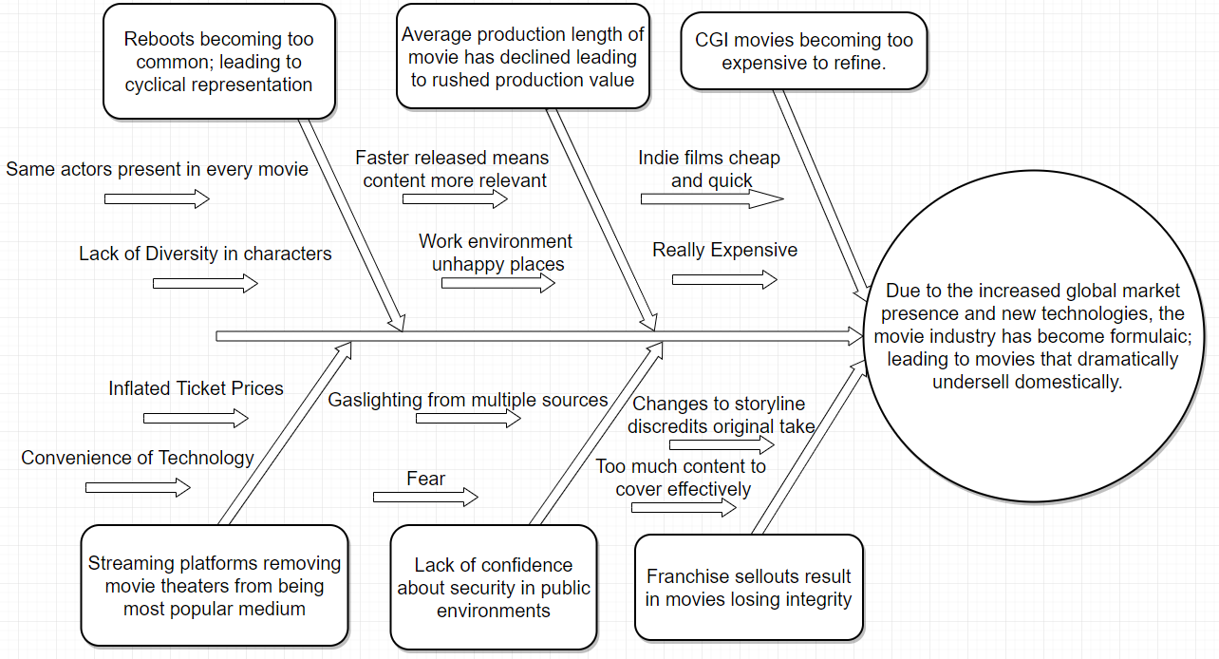

**Method 9:**

**Chapter 3**

We look to software and cloud usage and their importance in the success of a firm competing in the film industry.

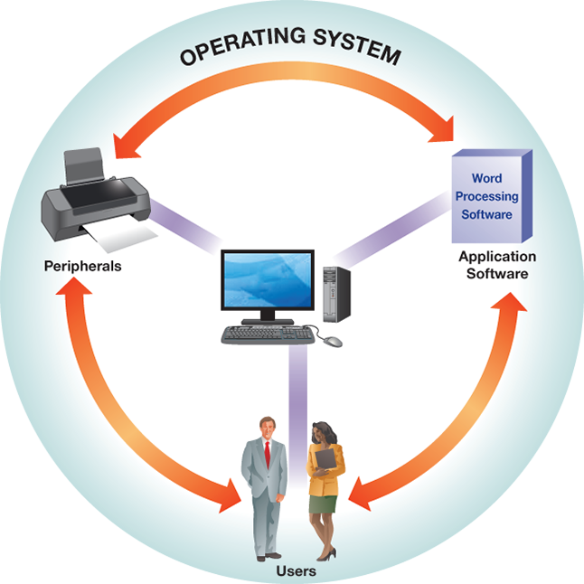

**System Software-** The harmony between the many different system software within a computer is what allows its users to accomplish their tasks so easily. This is apparent in the movie making process as well. Application software is necessary for movie editing because there are certain programs that deal exclusively with editing such as the Hollywood standard, Avid Media Composer ⁴⁶; Adobe Premiere; Final Cut; etc. Peripherals- such as a mouse or keyboard- are used extensively in the editing process to drag and drop the different clips and the keyboard being used for any editing shortcuts. The main player within system software is the operating system of the computer because this piece of software is in charge simplifying and executing commands from the user ranging from interpreting the input from the mouse or keyboard to storing the pieces of data that the user needs.

**Storage-** Storage has increasingly become more important in businesses because the government has made it mandatory for a business to archive any important documents and relevant internal communications through the Sarbanes-Oxley Act⁴⁷and it enables efficient storage and retrieval of data⁴⁷. Throughout the stages of pre-production of a film, there is a level of collaboration between many different bodies of people that must maintain a schedule. This level of collaboration is accomplished with the efficient use of storage of plans, schedule, and distribution of said information to everyone working on the project to ensure that deadlines are met⁴⁸. The necessity of storage and computing power also persists throughout the next step: the production process. These two are needed to keep any and all raw data of film- including the numerous different takes of different scenes- that will later be edited later in post-production and will need to be shared between different PCs in order to ensure that the movie can be worked on continuously⁴⁸. Storage is then utilized in the post-production stage of the movie as the average production requires an average of six terabytes (Plus the amount of storage of any backup systems in place) to maintain high quality video and any subsequent edits made to it⁴⁸.

**Cloud Computing-** In 2015, Netflix moved all of its data from being stored in data centers to the cloud⁴⁹. It has completely made the move to Amazon Web Services This is a financially smart move because the cost of having to maintain data centers is much greater than having its storage in the cloud. The utilization of Amazon Web Services has yielded many benefits for its customers. AWS has allowed for flexibility as users have no need to contact their service provider first before accessing the cloud as well as the ability to have computing resources to be scaled up or down in an instant. The ubiquity of cloud services due to it being accessed from the internet means that users can access applications in the cloud can be accessed from any place at any moment and have its resources be pooled together and distributed to multiple customers rather than having a customer assigned to one specific, physical machine2. Cloud computing is revolutionizing the way that firms in the industry are conducting business while simultaneously allowing new ones to enter at a much cheaper price.

**Demand Fluctuations-** Movie theaters experience many fluctuations throughout the year. As big blockbusters are released nationwide, many theaters- and streaming services that have the movie available- can expect a surge of demand (Ticket purchases) and a subsequent slump afterwards.

**Chapter 10**

*Criminals and Crimes*

Criminals, such as hackers or crackers, have become a major threat to the movie production industry. There are different reasons why hackers hack into a company. Some hackers are current or former employees that use their position to steal sensitive information for industrial sabotage and for personal gain reasons. Other hackers utilize their skillset for criminal intentions. Finally, a minority of hackers/crackers just snoop around without malicious intent. These hackers have become a problem in the movie production because companies run the risk of their intellectual property or financially records being compromised. Recently, Netflix, Sony, and Home Box Office (HBO), have been victims of cyberbullies that have stolen their intellectual property which resulted private information being publicly released.

*Cyber Terrorism and Piracy*

Cyber terrorism is the act of criminals using a computer to cause fear in society. The movie industry is particularly vulnerable to cyber terrorism. In November 2014, Sony was hacked by a group that called themselves Guardians of Peace (GOF). During this hack, skulls would appear on the computer screens of users; this caused chaos and panic across the industry. This hacker group exposed sensitive information, such as social security numbers and salary benefits, to the public. Furthermore, at least 5 films were released to the public through file sharing, which violated copyright infringement protections. ⁵1, ⁵2 As a result, Sony production experienced a loss of revenue with the release of these films. ‘Fury’, which was not yet released in theaters was being pirated; the film was found that approximately 888,000 different IP addresses downloaded the content. At the time of the data breach, this was one of the second highest films being downloaded. Likewise, ‘Annie’ was another film which fell victim to hacking which had been pirated 3 weeks before the film was to be released in theaters. ⁵⁰, ⁵**¹**, ⁵³ Lastly, another Sony production films that was hacked and had issues with the release was ‘The Interview’. GOF threatened many cinemas to an act of terrorism if the film was to be released in their theaters. They further threatened Sony production that top secrets would be exposed if they moved forward with the theatrical release. ⁵⁰Sony production was left with little alternative and had to pull the film from theatrical release. Piracy is a huge threat in the industry as it causes the film to lose potential revenue from box office sales.

*Managing Information System Security*

Management of company security within their information system is crucial. These companies must account for different security vulnerable events such as natural disasters, employee error, foreign travel, and outside cyber security hackers. When taking precautions in the security of the information system, the systems security team will assess the risk, develop a security strategy, implement systematic controls and training, and, finally, routinely monitor the security system. This is highly important especially if the company has already been a victim of cybercrime. For example, it is reported the HBO has been a victim of the largest cybercrime with approximately 1.5 terabytes of data taken from this crime. The data includes scripts, financial documents, company emails and customer information. It is important note that HBO increased their cybersecurity, so they will not be prone to another cyberattack. ⁵³

*Developing a Security Strategy*

When a company is trying to upgrade their cybersecurity, the most effective way to do so is by considering three different control systems. *Preventive control* tries to prevent any negative event from occurring; this could be done by ensuring that users are only allowed to access what is needed to perform their duties and restrict them from accessing other information that is not within their jurisdiction. *Detective control* is done by evaluating and determining if there was a breach in the cyber security. The last system is *corrective control* which focuses more on acting after the compromise has accrued and restoring the compromised data. It is important for the company to have a disaster recovery plan in case a problem arises, such as having a backup site. This is important because as we’ve seen before in production industries such as Sony, Netflix, and HBO, when there is a breach in their informational system sensitive information is release making the individual prone to potential fraudulent crimes. Cybersecurity can easily decrease the likelihood of any further threats to the company’s information system by taking preventative and corrective action to realize where the weaknesses lie in the company cyber security systems.

**Method 10:**

*The Click-and-Mortar Strategy*

This method is also known as the Bricks-and-clicks business strategy. In this strategy there is both a physical location as well as a virtual location. A portion of the movie production industries revenue is composed by licensing their product, therefore these products need to be sold either in a physical store location or through online sales. Disney for example, is one of the 10 largest movie production companies which has both a physical location such as Disneyland or Disney stores and sells directly to the customer through their online website which offers products at a discounted price. Having both a physical store and a virtual location can be beneficial to the company since it can increase revenue, but it can also bring complications to the company if their website seems to have security issue, its unappealing or if the website is difficult to use.

*Reintermediation*

Since the motion picture production sales are comprised of theaters box office sales, digital downloads and DVD sales, intermediaries are needed to sell and promote the industries products. The intermediary typically uses the click-and-mortar strategy where there is a physical location, or a virtual location were the products could be bought. For instance, in a movie theater individual can purchase a movie ticket directly in their physical location or they can skip the line and preorder their tickets through their online website. Middle men are essential in the sales for the film industry since many, unlike Disney, don’t have a physical location were customers can purchase their products directly through the company. The company therefore rely heavily on retail stores or virtual stores to sell their products which include as DVD sales, Digital downloads or products they’ve licensed.

*Long tail*

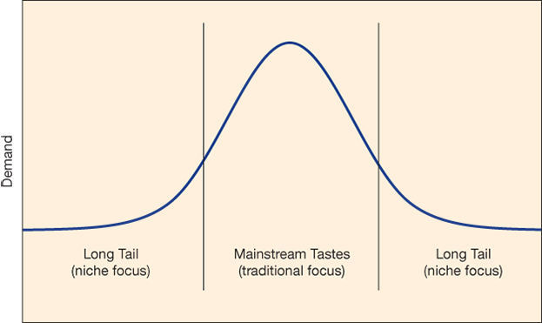

The long tail concept refers to the company’s focus in the niche markets instead of focusing on purely selling their products to a mainstream audience. Warner Bros. and Netflix’s both cater to different audiences. For instance, Warner Bros. is a large mainstream production company that caters to a large mainstream audience. Since Warner Bros. movie production can bring in a large audience their films are therefore previewed in a movie theater. Warner’s target market is geographically everyone who has access to a movie theater. In the other hand Netflix’s films are not previewed in a movie theater since they might not bring in a large audience creating a loss in any attempt in doing so therefore, Netflix focuses in producing its product to a niche market since they only target individuals who have access to their streaming online account and not to everyone geographically.

*Structural Firmness*

In order for the film industry to create a website that enhances the customers experience, the first necessity that needs to be met is the structural firmness of the website. This means making sure that the website is functioning correctly, and the security of the page is secure. If a website looks like it is not secure chances are the customer may feel uncomfortable with providing their sensitive information resulting in the customer no finalizing a payment. The website needs to be functioning correctly and properly for the customer to want to stay in the page and not turn to another competitor’s website. This means making sure that the web server reloads fast since many customers are impatient, reduce the amount of bad links in the page, and if an error occurs providing messages that are easy to analysis is important. For instance, if a customer is trying to become a member of Netflix and feels like the website is lagging, chances are that this customer has the impression that the service Netflix provides will be the same and choose not to obtain their service.

*Functional Convenience*

Functional convenience is another necessity that needs to be successfully created to enhance customers experience. If a website is difficult to navigate through, chances are the customer will not use the website. The page needs to be easy to navigate threw and give the customer the most convenience possible. For instance, Netflix website page is easy to use. Once there is an account the passcode is auto saved making it convenient for the customer, another convenience Netflix’s offers it that it saves the progress of a movie if the customer decides to watch it later, Netflix also saves the most recent films and the films are categorized based on genre.54

*Representational Delight*

Finally, the last thing needed to enhance customer experience is representational delight. This means that the page needs to be inviting through the customers eyes. This is essential since this will determine whether the customer says or leaves the site. Disney website for example has their page joyful, with colors and picture making it delightful to the customer

*Social Media Marketing*

Social media marketing has been an easy way for the movie production to promote their films with low to no cost. Disney for instance uses Facebook to promote their films by having a page called Disney movie reward where members can sign up and get rewards when purchasing movie tickets. With 2.5M followers to this page, it is easy for Disney to promote their production film onto this site by post upcoming movie clips as well as promote older movies from the past. Warner Bros. is another example of the popularity of using social media as a form of Marketing. Warner’s Facebook page currently has 3.5M followers which thy post upcoming film clips. When you enter their page the first thing you see is them promoting the film Aquaman, then there is a tab that directs you to a shop now were you can purchase the film digitally or in Blu-ray or DVD. Using social media is an advantage that allows the film industry to target their specific target market more effectively and efficiently with hardly any effort. 55

*Cryptocurrencies*

A more famous type of cryptocurrencies now and days is bitcoin. Since the use of credit card have become expensive, one option the movie production industry can turn to is the usage of bitcoin for large cost payments. This can be useful since cost from the process fee that debit card and credit card usually charge will be eliminated, which will rest in more revenue for the industry. Another thing to consider, since cryptocurrencies are starting to become more popular is figuring a a system in which customers are also allowed to make purchases using cryptocurrencies. One way to encourage customers to use this type of currency is by giving them discounts on product if payment is done via cryptocurrencies, this could be done since the cost the company would have normally incurred with the process fee would be eliminated.

**CITATION**

1. Kantor J, Twohey M. Harvey Weinstein Paid Off Sexual Harassment Accusers for Decades. The New York Times. https://www.nytimes.com/2017/10/05/us/harvey-weinstein-harassment-allegations.html. Published October 5, 2017. Accessed February 1, 2019.
2. Almukhtar S, Gold M, Buchanan L. After Weinstein: 71 Men Accused of Sexual Misconduct and Their Fall From Power. The New York Times. https://www.nytimes.com/interactive/2017/11/10/us/men-accused-sexual-misconduct-weinstein.html. Published November 11, 2017. Accessed February 1, 2019.
3. Puente M, Kelly C. How common is sexual misconduct in Hollywood? USA Today. https://www.usatoday.com/story/life/people/2018/02/20/how-common-sexual-misconduct-hollywood/1083964001/. Published February 23, 2018. Accessed February 1, 2019.
4. Margolis Z. Guidelines are a start, but sexual harassment in the film industry is not going away soon. The Guardian. https://www.theguardian.com/film/2018/jan/26/sexual-harassment-film-industry-producers-guild-of-america. Published January 26, 2018. Accessed February 1, 2019.
5. Sanchez F. What's Hollywood got against Latinos? CNN. https://www.cnn.com/2017/04/03/opinions/latinos-hollywood-sanchez/index.html. Published April 3, 2017. Accessed February 1, 2019.
6. Esai Morales On Latinos, Hollywood and Trump. NBCNews.com. https://www.nbcnews.com/news/latino/esai-morales-latinos-hollywood-trump-n426866. Accessed February 1, 2019.
7. Dodd CJ. Theatrical Market Statistics. 2016.
8. Cut! How the Entertainment Industry is Reducing Environmental Impacts. State of the Planet. https://blogs.ei.columbia.edu/2018/03/29/entertainment-industry-sustainability/. Published March 29, 2018. Accessed February 1, 2019.
9. Arnold A. Is there any money left to be made in the movies? ABC News. https://www.abc.net.au/news/2017-02-25/economics-of-movie-making/8292352. Published February 26, 2017. Accessed February 1, 2019.
10. Kenton W. Porter's 5 Forces. Investopedia. https://www.investopedia.com/terms/p/porter.asp. Published December 13, 2018. Accessed February 1, 2019.
11. Film Production Company SWOT Analysis.<http://www.thefinanceresource.com/swot-analysis/film-production-company-swot-analysis.aspx>. Accessed February 1, 2019
12. The Top 10 Movie Production Companies of All Time.<https://reelrundown.com/film-industry/Top-10-Movie-Production-Companies>. Accessed February 2, 2019
13. Entertainment Industry Associations, Guilds, and Unions.<http://film.ca.gov/production/associations-guilds/>. Accessed February 3, 2019
14. Entertainment Work Permits – Employment of Minors as Child Actors.<http://film.ca.gov/production/work-permits/>. Accessed February 3, 2019
15. Valacich J. Information Systems Today Mymislab With Pearson Etext Access Card Managing in a Digital World. Pearson College Div; 2015.
16. Bumblebee (2018). Box Office Mojo. <https://www.boxofficemojo.com/movies/?id=transformers6.htm>. Accessed February 3, 2019.
17. Valacich, J. (2019). Information Systems Today: Managing the Digital World. 8th ed. Pearson.
18. Quora. (2019). How much does it cost to rent a helicopter for aerial photography?. [online] Available at: https://www.quora.com/How-much-does-it-cost-to-rent-a-helicopter-for-aerial-photography [Accessed 15 Feb. 2019].
19. Valera, S. (2018). Sony Seeks Patent for 'Spider-Man: Into the Spider-Verse' Animation Tech - Geek.com. [online] Geek.com. Available at: https://www.geek.com/movies/sony-seeks-patent-for-spider-man-into-the-spider-verse-animation-tech-1765786/ [Accessed 15 Feb. 2019].
20. Arnold, T. (2017). These 35 Creators Earned Over $150,000 Each on Patreon in 2016 – Meet Them! | Patreon Blog. [online] Blog.patreon.com. Available at: https://blog.patreon.com/top-earners-2016 [Accessed 17 Feb. 2019].
21. How James Cameron's Innovative New 3D Tech Created *Avatar*. <https://www.popularmechanics.com/culture/movies/a5067/4339455/>. Accessed February 16, 2019
22. Five years ago, Avatar grossed $2.7 billion But left no pop culture foot print. <https://www.forbes.com/sites/scottmendelson/2014/12/18/avatar-became-the-highest-grossing-film-of-all-time-while-leaving-no-pop-culture-footprint/#133bfd9c6159>. Accessed February 17, 2019
23. Valacich J. Information Systems Today Mymislab With Pearson Etext Access Card Managing in a Digital World. Pearson College Div; 2015. Accessed February 17, 2019
24. Statista. (2019). *Comcast: no of video subscribers in the U.S. 2018 | Statistic*. [online] Available at: https://www.statista.com/statistics/497279/comcast-number-video-subscribers-usa/ [Accessed 17 Feb. 2019].
25. MBA Skool-Study.Learn.Share. (2019). *Comcast Marketing Mix (4Ps) Strategy | MBA Skool-Study.Learn.Share.*. [online] Available at: https://www.mbaskool.com/marketing-mix/services/17105-comcast.html [Accessed 19 Feb. 2019].
26. Walters, N. (2019). *Netflix Clarifies $2 Billion Marketing Strategy Ahead of 2019 -- The Motley Fool*. [online] The Motley Fool. Available at: https://www.fool.com/investing/2018/10/27/netflix-clarifies-marketing-strategy-ahead-of-2019.aspx
27. Otto. Netflix marketing plan. Slideshare.net. https://www.slideshare.net/evelyneringia/netflix-markeitn. Published 2019. Accessed February 19, 2019.
28. Comcast b, Columbia D, Hampshire N et al. Coverage & Availability Map | BroadbandNow.com. Broadband Now. https://broadbandnow.com/XFINITY. Published 2019. Accessed February 19, 2019.
29. Bhasin H. Marketing Mix of Xfinity - Xfinity Marketing Mix and 4 P's of Xfinity. Marketing91. https://www.marketing91.com/marketing-mix-xfinity. Published 2019. Accessed February 19, 2019.
30. Na, Yon (2019), “Warner Brother's Q&A,” personal, .
31. Where Data and the Business Meet. <https://www.the-numbers.com/movie/budgets>. Accessed February 19, 2019
32. Statista. (2019). Comcast: no of video subscribers in the U.S. 2018 | Statistic. [online] Available at: https://www.statista.com/statistics/497279/comcast-number-video-subscribers-usa/ [Accessed 17 Feb. 2019].
33. MBA Skool-Study.Learn.Share. (2019). Comcast Marketing Mix (4Ps) Strategy | MBA Skool-Study.Learn.Share.. [online] Available at: https://www.mbaskool.com/marketing-mix/services/17105-comcast.html [Accessed 19 Feb. 2019].
34. Walters, N. (2019). Netflix Clarifies $2 Billion Marketing Strategy Ahead of 2019 -- The Motley Fool. [online] The Motley Fool. Available at: https://www.fool.com/investing/2018/10/27/netflix-clarifies-marketing-strategy-ahead-of-2019.aspx
35. Otto. Netflix marketing plan. Slideshare.net. https://www.slideshare.net/evelyneringia/netflix-markeitn. Published 2019. Accessed February 19, 2019.
36. Comcast b, Columbia D, Hampshire N et al. Coverage & Availability Map | BroadbandNow.com. Broadband Now. https://broadbandnow.com/XFINITY. Published 2019. Accessed February 19, 2019.
37. Bhasin H. Marketing Mix of Xfinity - Xfinity Marketing Mix and 4 P's of Xfinity. Marketing91. https://www.marketing91.com/marketing-mix-xfinity. Published 2019. Accessed February 19, 2019.
38. Boxofficemojo.com. (2019). *Box Office Mojo*. [online] Available at: https://www.boxofficemojo.com
39. Stephen Follows. (2019). *How long does the average Hollywood movie take to make?*. [online] Available at: https://stephenfollows.com/how-long-the-average-hollywood-movie-take-to-make/
40. The Ringer. (2019). *Steven Soderbergh’s ‘High Flying Bird’ and the Rise of iPhone Films*. [online] Available at: https://www.theringer.com/movies/2019/2/7/18214924/steven-soderbergh-high-flying-bird-iphone-tangerine-unsane-netflix
41. https://www.forbes.com/sites/sophiecharara/2018/12/31/netflix-bird-box-views-45-million/#663e2b561037 ³ https://www.rottentomatoes.com/top/bestofrt/
42. Berman, N. (2019). *How Much It Costs to Make a Single Episode of Game of Thrones*. [online] Money Inc. Available at: https://moneyinc.com/much-costs-make-single-episode-game-thrones/ [Accessed 6 Mar. 2019].
43. Ibisworld.com. (2019). *Movie Theaters in the US. Industry Market Research Reports, Trends, Statistics, Data, Forecasts*. [online] Available at: https://www.ibisworld.com/industry-trends/market-research-reports/information/motion-picture-sound-recording-industries/movie-theaters.html
44. https://www.politico.com/magazine/story/2017/10/04/mass-shootings-more-deadly-frequent-research-215678
45. Nytimes.com. (2019). *Mass Shootings Add Anxiety to Movie Theater Visits*. [online] Available at: https://www.nytimes.com/2015/12/16/business/mass-shootings-add-anxiety-to-movie-theater-visits.html
46. Quora. (2019). What kind of software is used in film making in Hollywood? What kind of special software is being used for illustration, effects, montage, animation, etc.? Is Adobe one of the players?. [online] Available at: https://www.quora.com/What-kind-of-software-is-used-in-film-making-in-Hollywood-What-kind-of-special-software-is-being-used-for-illustration-effects-montage-animation-etc-Is-Adobe-one-of-the-players [Accessed 3 Mar. 2019].
47. VALACICH, J. (2017). INFORMATION SYSTEMS TODAY. 8th ed. [S.l.]: PRENTICE HALL, pp.102
48. Olmsted, E. (2019). Information Technology and the Movie Making Process. [online] Ols.technology. Available at: https://www.ols.technology/newsletter-content/information-technology-and-the-movie-making-process [Accessed 3 Mar. 2019
49. Chernicoff, D. (2019). Netflix closes data centers and goes to public cloud. [online] Datacenterdynamics.com. Available at: https://www.datacenterdynamics.com/news/netflix-closes-data-centers-and-goes-to-public-cloud/ [Accessed 5 Mar. 2019]
50. The Interview: A guide to the cyber attack on Hollywood. https://www.bbc.com/news/entertainment-arts-30512032. Accessed March 3, 2019
51. Hollywood's hacking pains are bigger than movie leaks. https://phys.org/news/2017-08-hollywood-hacking-pains-bigger-movie.html. Accessed March 3, 2019
52. HBO Hack Could Be the Biggest Industry Hacking Ever — Everything You Need to Know<https://www.indiewire.com/2017/08/hbo-hack-details-fbi-investigation-sony-biggest-history-1201862895/>. Accessed March 2, 2019
53. Sony’s New Movies Leak Online Following Hack Attack. https://variety.com/2014/digital/news/new-sony-films-pirated-in-wake-of-hack-attack-1201367036/. Accessed March 3, 2019
54. Netflix.https://www.netflix.com/. Accessed March 20
55. Facebook.https://www.facebook.com/Disney/ Accessed March 21